Captain Mapping

Overview:The Captain app Mapping feature allows the captain to register device details with the system. For captain mapping we have 2 methods.
- Mapping from POS (Recommended)
- Mapping from Dashboard
Prerequisites:
- Captain App Service Must be activated.
- The network should be the same in the captain & Server system.
1: Mapping from POS

Overview:This feature is allowed to users map captain app without login web dashboards with hassle free process even not having to set any IP address if internet connection is the same just scan the QR from caption app device which is displayed in POS System.

Step 1: Open POS Click On Operation
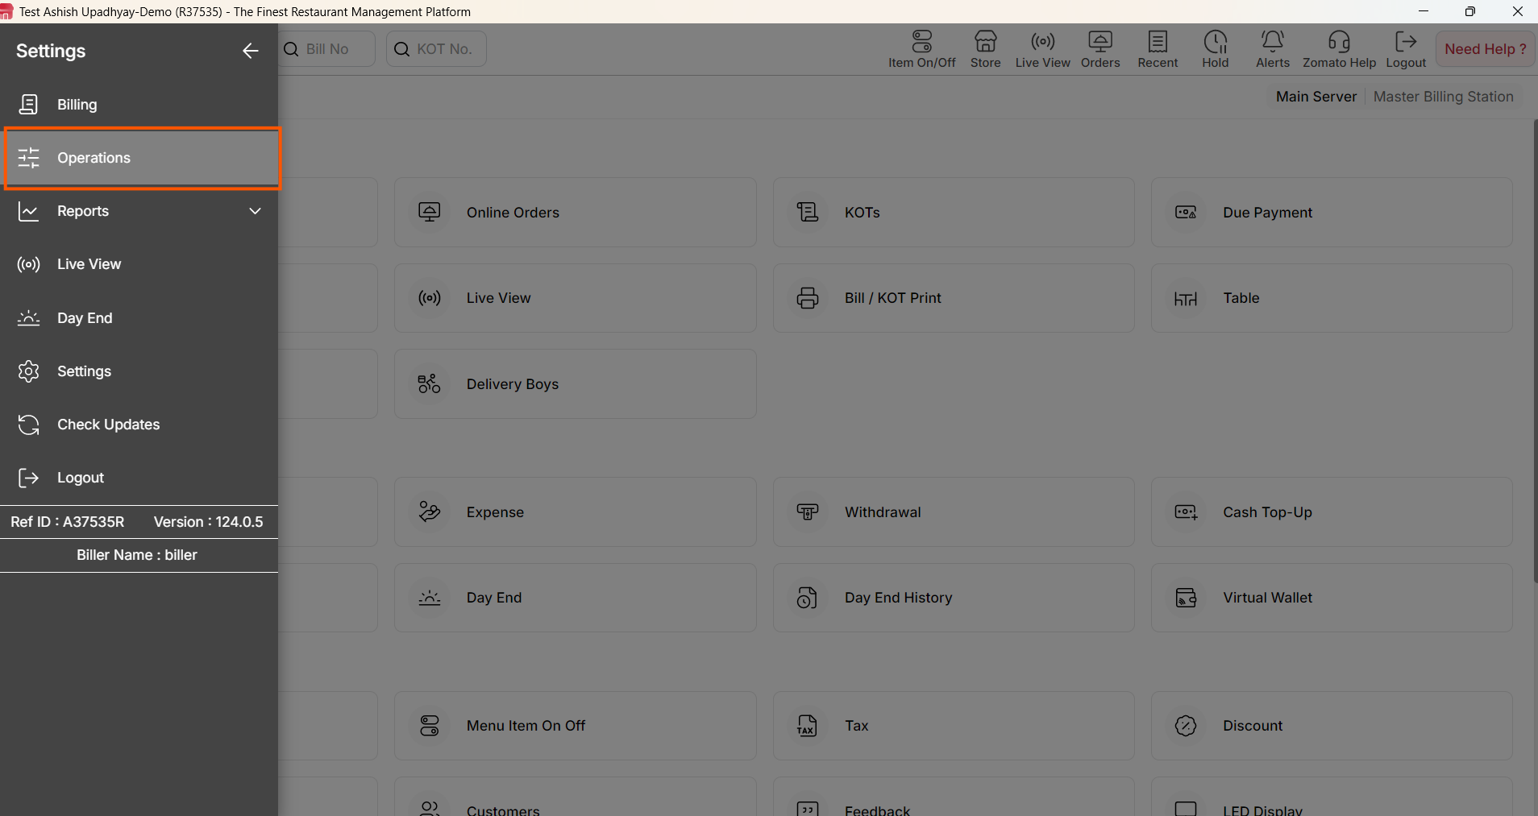
{ Image Name: POS Operation ,
Description:The highlighted section indicates the Operation.This is Step 1 to Find Generate Code option in POS }
Step 2: Click on Connect Captain & Secondary POS Options in the Operation section in POS.

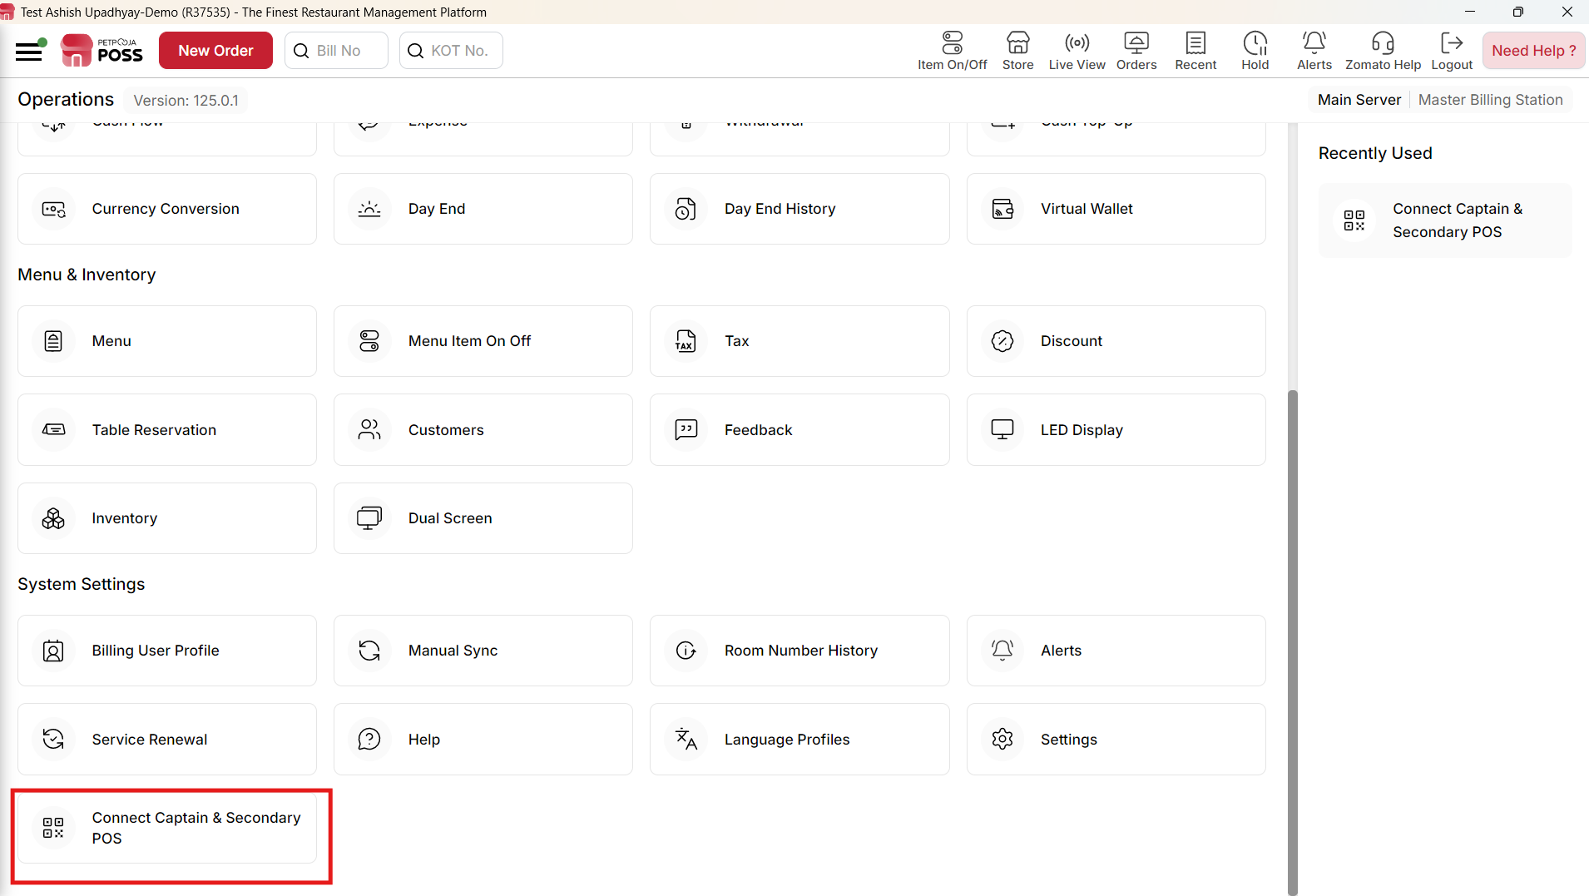
{ Image Name: Settings in POS,
Description:The highlighted section indicates the Connect Captain & Secondary POS Under the System Settings section.This is Step 2 to Find Generate Code option in POS }

Step 3:.Click on Captain App option inside the Connect Captain & Secondary POS Section
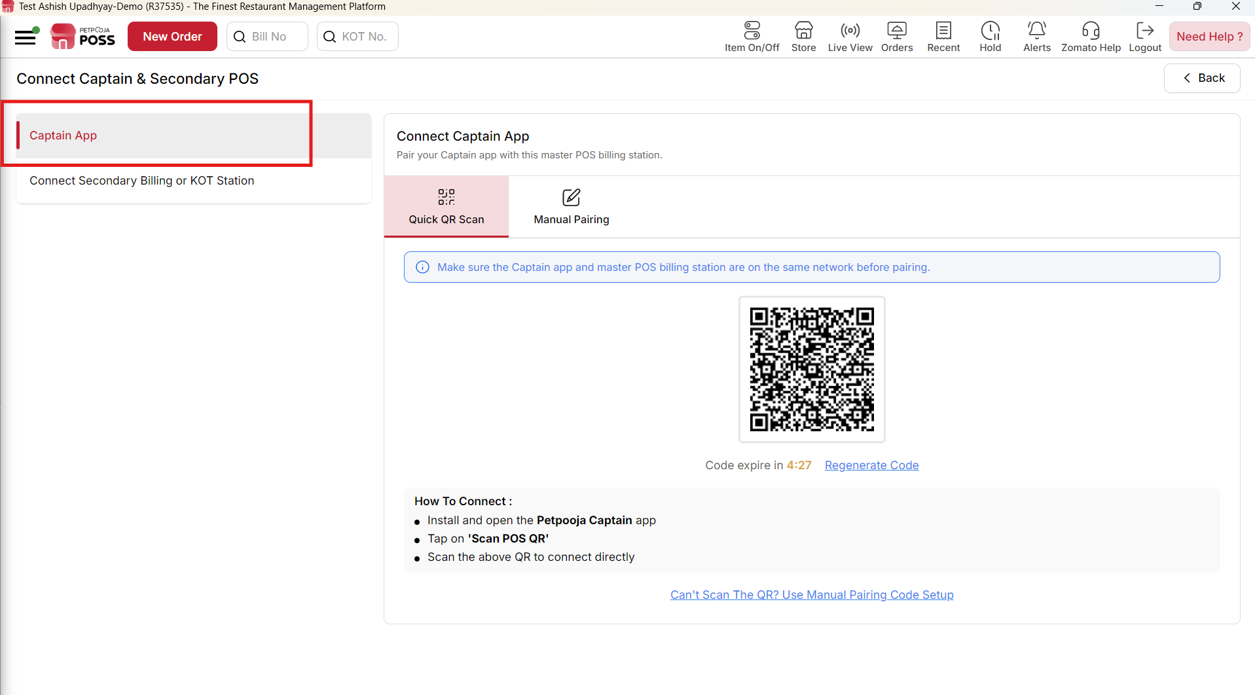
{ Image Name: Generate Code,
Description:The highlighted section indicates the Generate Code.This is Step 3 to Find Generate Code option in POS }

Methods for Connecting the Captain App in POS
There are two methods available for mapping the Captain App to the POS system. Either method can be used successfully to complete the pairing process:
- Quick QR Scan
- Manual Pairing

1. Quick QR Scan
Overview: This is a fast and highly recommended method for mapping the Captain device to the POS system. Simply connect both devices to the same network and scan the QR code. The system will automatically map the devices for a seamless, hassle-free setup.
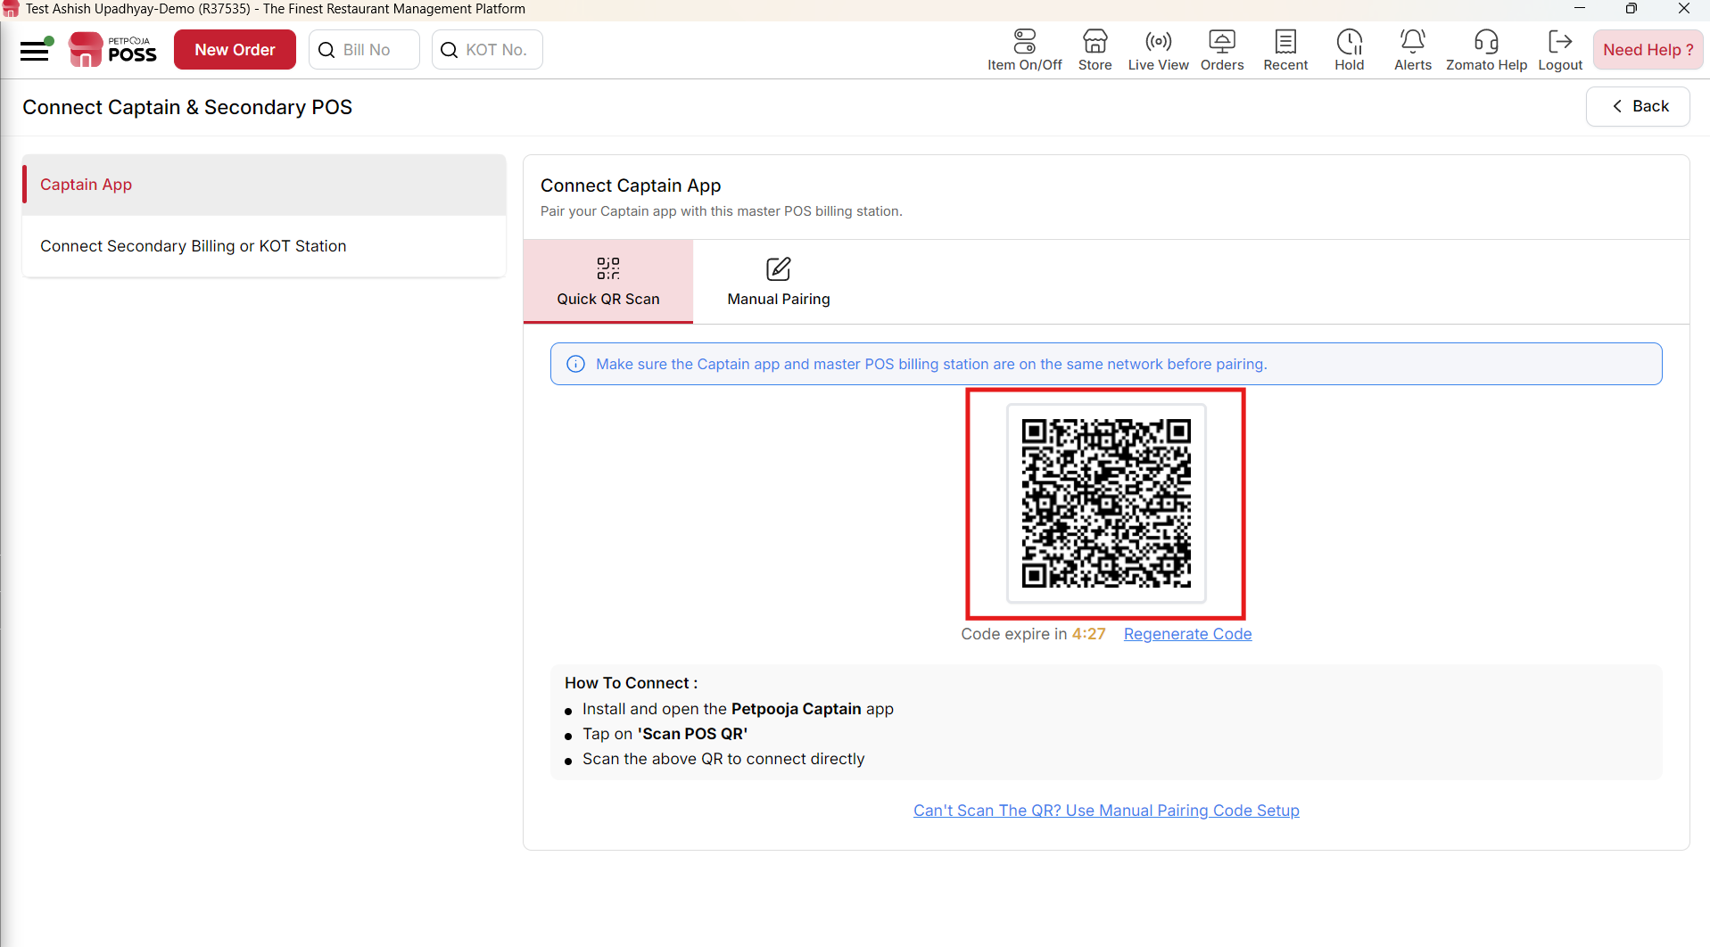
{ Image Name: Quick QR Scan,
Description:The highlighted section indicates the Quick QR Scan Method .This is Step to Find Generate Code option in POS }

2. Manual Pairing
Overview: This is an alternative manual process used for mapping the Captain App to the POS system. In this method, you will need to manually enter the code displayed on the POS system's Manual Mapping page directly into the Captain App.
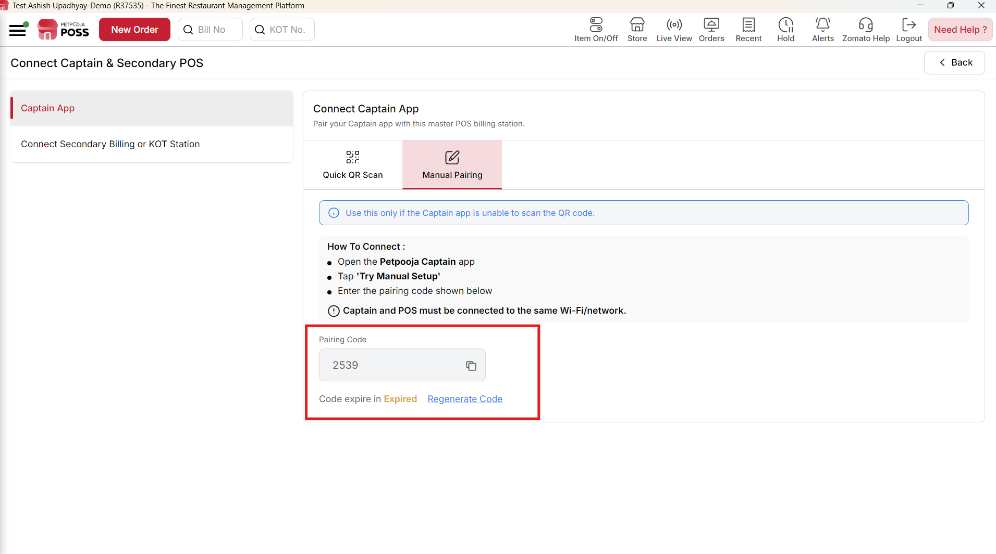
{ Image Name: Manual Paring ,
Description:The highlighted section indicates the Manual Paring Method .This is step to map captain app in POS system}

Step 5:. Open Captain app & Click on Scan QR Code
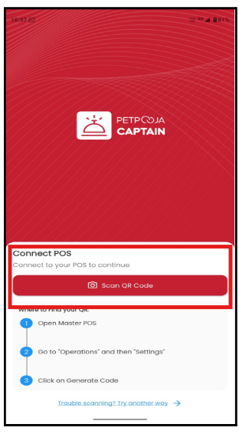
{ Image Name: Scan QR Code in captain app,
Description:The highlighted section indicates the Generate Code in captain app.This is Step 5 to Map captain app }

Step 6: After successful mapping, the Captain App login screen will be displayed.
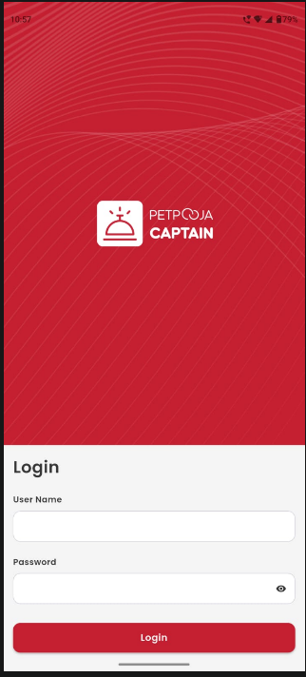
{ Image Name: Login screen captain app ,
Description:The above image showing login screen after successful mapping .This is Step 6 and last steps for Map captain app }

2: Mapping from Dashboard
Overview:The Mapping from Dashboard feature allows users to map the Captain App with the selected outlet directly from the Petpooja Dashboard using a Unique Mapping Code generated in the Captain App. Once the code is entered and verified, the Captain App is successfully linked to the outlet, enabling seamless communication between the Dashboard and the Captain App. This method provides a quick and secure way to complete device mapping without requiring manual IP configuration.

Step 1: Open dashboard URL: billing.petpooja.com
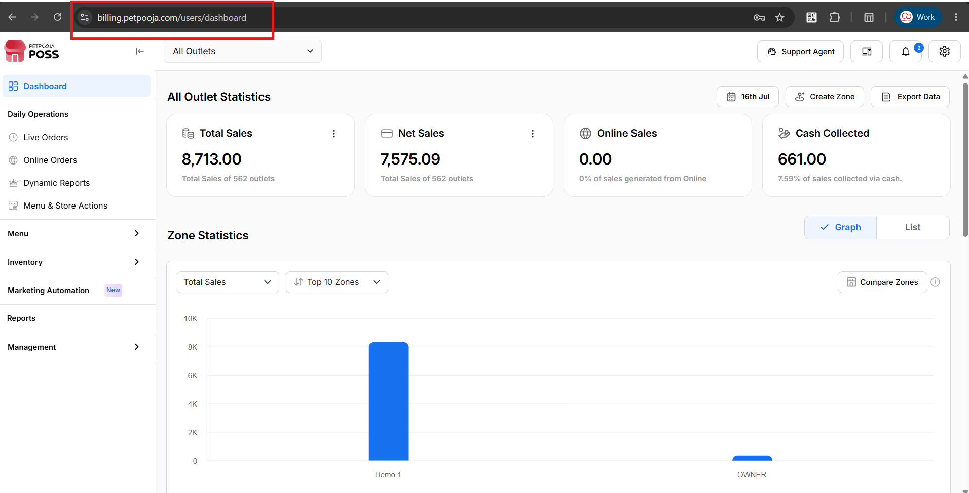
{ Image Name: After Dashboard login Page ,
Description: The highlighted section indicates dashboard URL. This is Step 1 to reach at Captain App Mapping from dashboard page }

Step 2: After that, go to billing.petpooja.com. On the top-right side of the screen, you will see the "Device Mapping" option. Click on it.
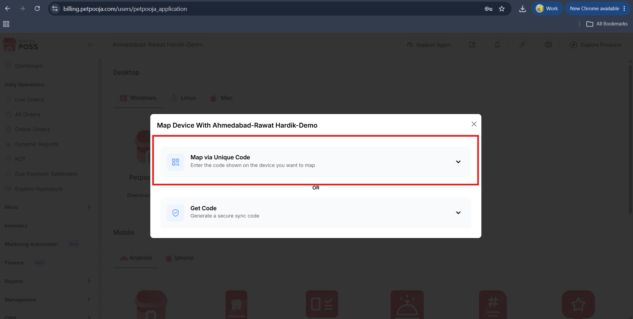
{ Image Name: Device Mapping,
Description: The highlighted option shows a map via a unique code option in dashboard
This is step 2 for Captain App Map via Unique Code }

Step 3: Copy the Unique Code from captain App enter here.
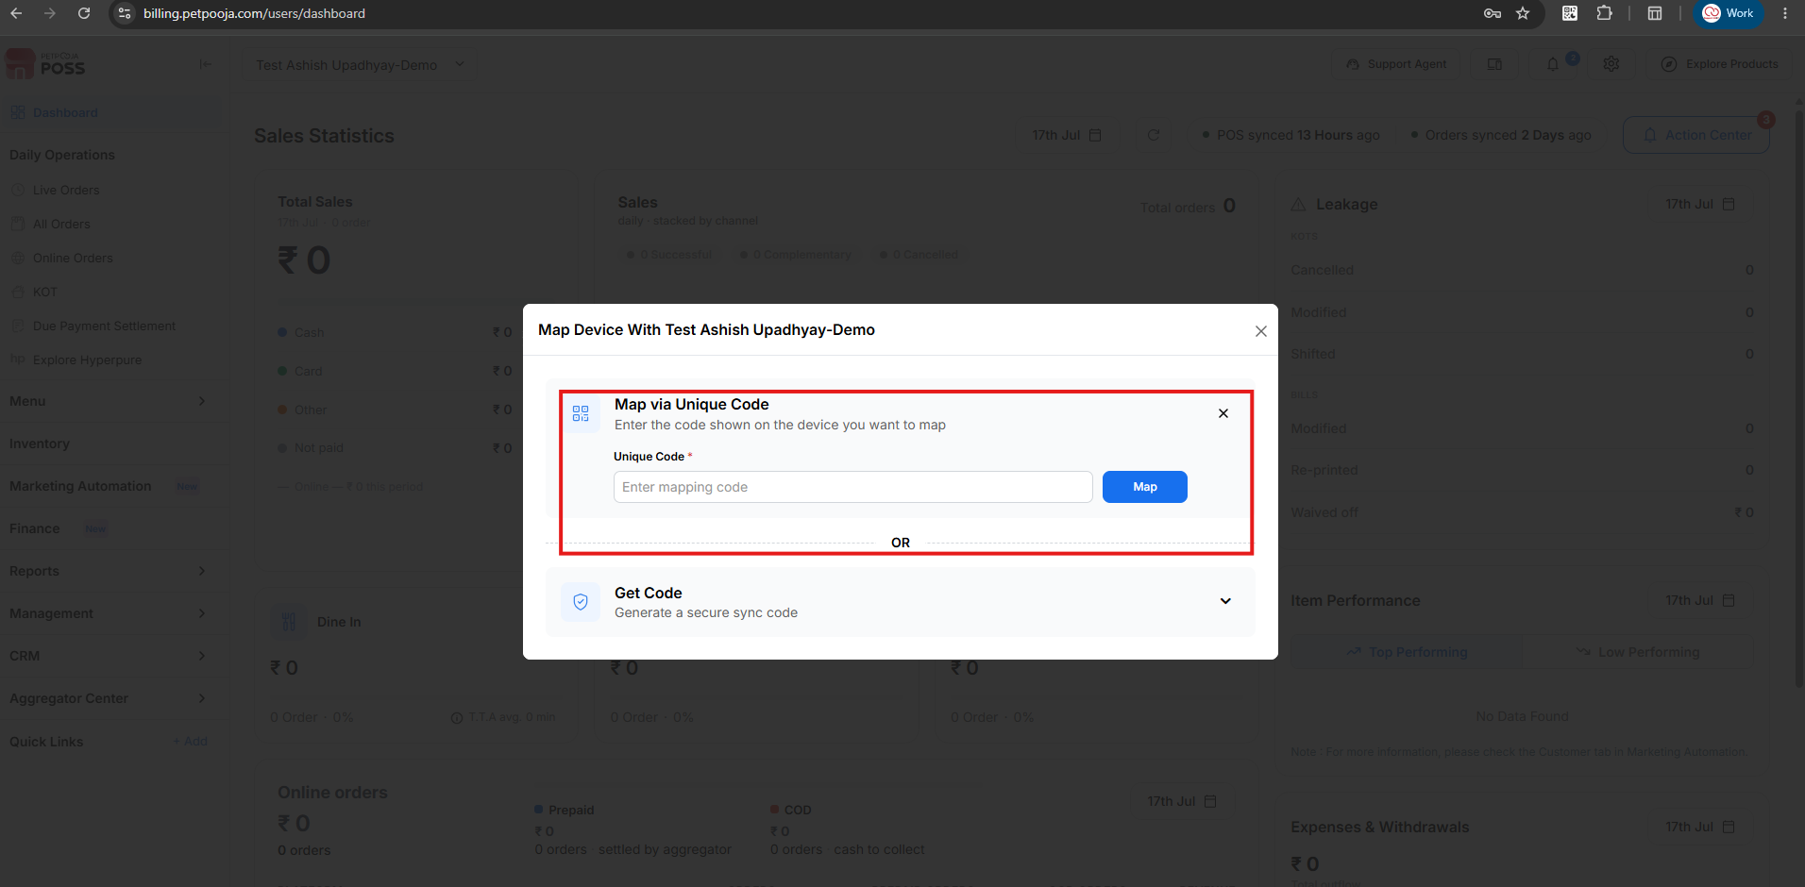
{ Image Name: Enter Mapping code,
Description: The highlighted option shows a Enter Mapping Code option in dashboard
This is step 3 for Captain App Map via Unique Code }

3: Captain App Troubleshooting Steps
- QR Code Not Scanning: This typically happens if camera permissions are denied or the QR code is physically unclear. Resolution: Grant the necessary camera permissions on the device and regenerate the QR code.
- Mapping Failed: This occurs when the devices are operating on different networks. Resolution: Ensure both the POS Server and the Captain device are connected to the exact same Wi-Fi or LAN network.
- QR Code Expired: This indicates that the QR code session has timed out. Resolution: Generate a new QR code from the POS system and scan it again.
- Captain App Cannot Connect: This is usually caused by the Captain App Service being disabled. Resolution: Verify in the system settings that the Captain App Service is activated for that specific outlet.

